Delivery for Data Engineering 2, Assignment 1

Myitzu: ID 2300350

David: ID 2302806

1. **Key Generation Command:**



ssh-keygen -t rsa -f ./keypairs/my_keypair -N ''

1. **Contents of the private and public keys:**

*Private:*

**

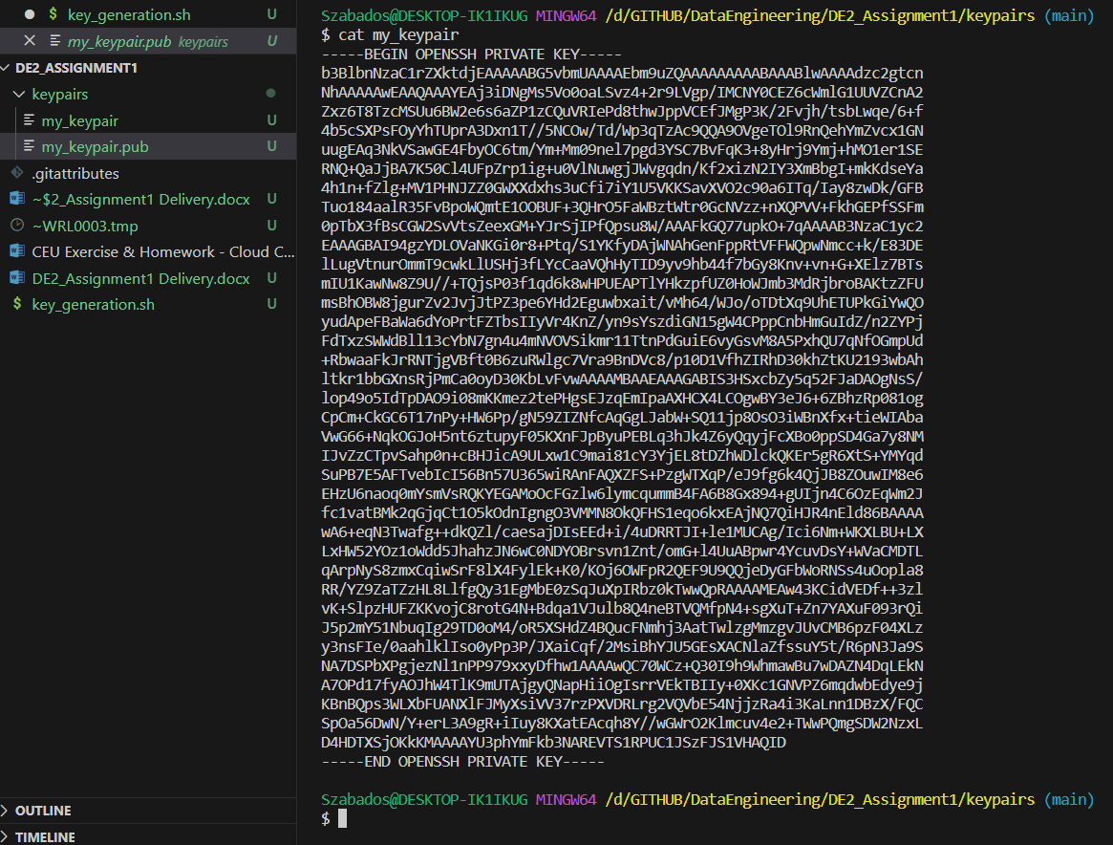

*Public:*

**

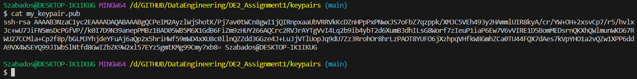

1. **Visitor Encryption (Made in Linux)**



import os

from pathlib import Path

from Cryptodome.Cipher import PKCS1_OAEP

from Cryptodome.PublicKey import RSA

PROJECTFOLDER = os.getcwd()

print(PROJECTFOLDER)

PUBLIC_KEY_FILE = PROJECTFOLDER + "/my_keypair.pub"

print(PUBLIC_KEY_FILE)

assert os.path.isfile(PUBLIC_KEY_FILE)

short_secret_message = "The pink otter is cheesy".encode("utf-8")

key = RSA.importKey(open(PUBLIC_KEY_FILE).read())

public_key_cipher = PKCS1_OAEP.new(key)

encrypted_message = public_key_cipher.encrypt(short_secret_message)

print(f"Encrypted message:")

print(encrypted_message)

ENCRYPTED_MESSAGE_FILE = PROJECTFOLDER + "/encrypted_message.bin"

with open(ENCRYPTED_MESSAGE_FILE, "wb") as f:

    f.write(encrypted_message)

1. **CEU Decryption (Made in Windows)**



# %%

import os

from pathlib import Path

from Cryptodome.Cipher import PKCS1_OAEP

from Cryptodome.PublicKey import RSA

PROJECT_FOLDER = os.getcwd()

print(PROJECT_FOLDER)

PRIVATE_KEY_FILE = PROJECT_FOLDER + "\keypairs\my_keypair"

print(PRIVATE_KEY_FILE)

assert os.path.isfile(PRIVATE_KEY_FILE)

# %%

# Load the private key from file

with open(PRIVATE_KEY_FILE, "r", encoding="utf8") as key_file:

    private_key = RSA.import_key(key_file.read())

# %%

ENCRYPTED_MESSAGE_FILE = PROJECT_FOLDER + "\encrypted_message.bin"

# %%

with open(ENCRYPTED_MESSAGE_FILE, "rb") as f:

    encrypted_message_from_file = f.read()

private_key_cipher = PKCS1_OAEP.new(private_key)

decrypted_message = private_key_cipher.decrypt(encrypted_message_from_file)

print(f"Decrypted message: {decrypted_message.decode('utf-8')}")

# %%

**Decrypted message:**

